CHINESE FLAGSHIP SECONDARY CURRICULUM
CHINESE – Level 1
Unit 4: At School
Assessment: Interpretive Reading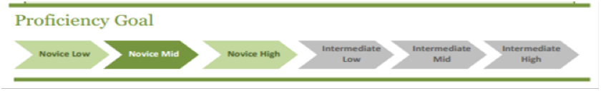
Scenario 1 | Objectives
It’s the week before the school starts. You are shopping for school supplies for the new year. Draw pictures that illustrate the 6 different supply categories below.  1. 三本（笔记）本 子  2．两支红色的笔  3．三支黑色的笔  4．一把尺  5．五支铅笔  6．两个橡皮 | - I can recognize the names of different school supplies items

Scenario 2 | Objectives
You are one of the “school ambassadors” and one new Chinese exchange student just wrote you an email asking questions about the school. Read the email and answer the following questions:  同学，你好：  我是李朋，新来的中国学生。上次在中文课和你见面，你还记得吗？  我想请你帮忙，可以吗？我觉得美国历史有一点儿难，还有英语课也很难。你可以帮我学习美国历史和练习英语吗？真不好意思！  我星期二下午三点都在图书馆，可以一起学习吗？我的课程表在附件，看看有没有你方便的时间。  我的电话是614-456-7890。  谢谢  李朋 | Questions:  - What does 李朋 need help with?  - When does 李朋 want to get together?  - How could you help 李朋?
Adapted from Jefferson County Public Schools, KY, 2011

